LAB EXPERIMENT

SET 28: VEHICLE PERFORMANCE ANALYSIS

Department | AIDS
Course Code / Course Name | DSA0602 / Data Handling and Visualization
Experiment | Data Visualization using R and Tableau
Name | D.HEMASREE
Register Number | 1925224114
Date | 22 October 2026
Day | Thursday

Aim
To analyze vehicle performance data using a violin plot, a scatter plot and a correlation heatmap in R, and to build an interactive dashboard using Tableau that highlights vehicles balancing fuel efficiency and high performance.

Dataset: Vehicle Performance

Vehicle_ID | Engine_Size (L) | Horsepower | Fuel_Efficiency (km/l) | Top_Speed (km/h) | Safety_Rating
V1 | 1.5 | 110 | 18 | 180 | 4
V2 | 2.0 | 150 | 15 | 200 | 5
V3 | 3.0 | 250 | 12 | 250 | 5
V4 | 2.5 | 200 | 14 | 220 | 4
V5 | 1.8 | 130 | 17 | 190 | 3

PROGRAM 1: Violin Plot of Fuel Efficiency by Safety Rating
Develop a violin plot to compare the distribution of Fuel_Efficiency across different Safety_Rating categories. Examine the spread, central tendency and variability within each group.
# Dataset
vehicles <- data.frame(
Vehicle_ID
Engine_Size Horsepower
= c("V1", "V2", "V3", "V4", "V5"),
= c(1.5, 2.0, 3.0, 2.5, 1.8),
= c(110, 150, 250, 200, 130),
Fuel_Efficiency = c(18, 15, 12, 14, 17),
Top_Speed = c(180, 200, 250, 220, 190),
Safety_Rating = c(4, 5, 5, 4, 3)
)

library(ggplot2)

# Violin plot of Fuel_Efficiency across Safety_Rating categories ggplot(vehicles, aes(x = factor(Safety_Rating),
y = Fuel_Efficiency,
fill = factor(Safety_Rating))) + geom_violin(trim = FALSE, alpha = 0.8) + geom_boxplot(width = 0.1, fill = "white") + geom_jitter(width = 0.05, size = 2) +
labs(title = "Fuel Efficiency by Safety Rating",

x = "Safety Rating",
y = "Fuel Efficiency (km/l)", fill = "Safety Rating")

# Summary statistics for each group aggregate(Fuel_Efficiency ~ Safety_Rating, data = vehicles,
FUN = function(x) c(Mean = mean(x), Median = median(x),
SD = sd(x), Min = min(x), Max = max(x)))

OUTPUT:
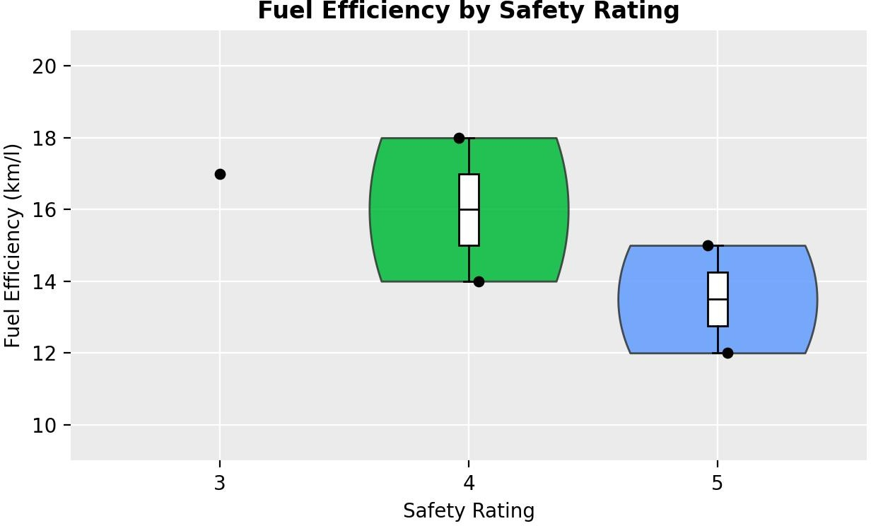
Output 1: Fuel Efficiency by Safety Rating (Violin Plot)

Safety_Rating | Vehicles | Mean | Median | Range | Std. Dev.
3 | 1 (V5) | 17.0 | 17.0 | 17 | –
4 | 2 (V1, V4) | 16.0 | 16.0 | 14 – 18 | 2.83
5 | 2 (V2, V3) | 13.5 | 13.5 | 12 – 15 | 2.12

Observation:
Central tendency falls as the safety rating rises: the median fuel efficiency is 17 km/l for rating 3, 16 km/l for rating 4 and 13.5 km/l for rating 5. Rating 4 shows the widest spread (14 to 18 km/l, SD 2.83) because it contains both the most efficient vehicle (V1) and a mid-range one (V4), while rating 5 is lower and tighter (12 to 15 km/l). Rating 3 has only one vehicle, so no violin shape can be drawn for it and only its point is shown. This suggests that the higher-rated vehicles in this dataset tend to be the larger, more powerful ones, which use more fuel. With only 1 to 2 vehicles per group, this is an indication of a pattern and not a firm conclusion.

PROGRAM 2: Scatter Plot of Horsepower vs Top Speed
Construct a scatter plot to explore the relationship between Horsepower and Top_Speed using colour to show Engine_Size. Analyze the strength and direction of the correlation and find observable performance trends.
ggplot(vehicles, aes(x = Horsepower, y = Top_Speed,
color = Engine_Size)) + geom_point(size = 4) +
geom_smooth(method = "lm", se = FALSE,
color = "grey40", linetype = "dashed") + geom_text(aes(label = Vehicle_ID), vjust = -1, color = "black") + scale_color_viridis_c(direction = -1) +
labs(title = "Horsepower vs Top Speed", x = "Horsepower",
y = "Top Speed (km/h)", color = "Engine Size (L)")

# Strength and direction of the relationship cor(vehicles$Horsepower, vehicles$Top_Speed) coef(lm(Top_Speed ~ Horsepower, data = vehicles))

OUTPUT:
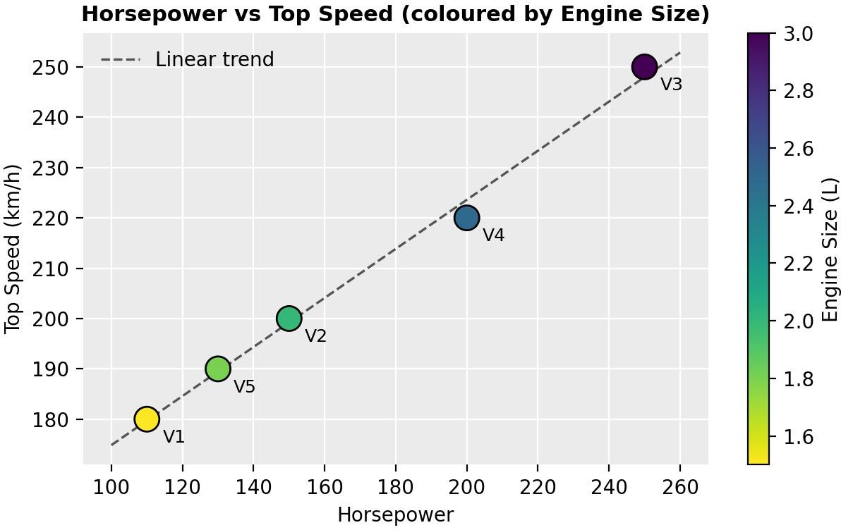
Output 2: Horsepower vs Top Speed (Scatter Plot)

Observation:
The points lie almost on a straight line rising to the right, so the correlation is very strong and positive (r = 0.997). The fitted line shows that each additional 10 horsepower adds about 4.9 km/h to the top speed. The colour scale shows that Engine_Size grows along the same line: V1 (1.5 L, 110 hp) is the slowest at 180 km/h and V3 (3.0 L, 250 hp) is the fastest at 250 km/h. No vehicle lies far from the trend, so there are no outliers. In short, a larger, more powerful engine gives a higher top speed.

PROGRAM 3: Correlation Heatmap of Numerical Variables
Create a correlation heatmap for all numerical variables in the dataset. Identify the variables most strongly associated with Top_Speed and their influence on overall vehicle performance.
# Select the numerical variables and compute the correlation matrix num_vars <- vehicles[, c("Engine_Size", "Horsepower",
"Fuel_Efficiency", "Top_Speed", "Safety_Rating")]
cor_mat <- round(cor(num_vars), 2) print(cor_mat)

# Convert the matrix to long format for ggplot2 cor_df <- as.data.frame(as.table(cor_mat)) names(cor_df) <- c("Var1", "Var2", "Correlation")

# Correlation heatmap
ggplot(cor_df, aes(x = Var1, y = Var2, fill = Correlation)) + geom_tile(color = "white") +
geom_text(aes(label = Correlation), size = 4) + scale_fill_gradient2(low = "firebrick", mid = "white",
high = "steelblue", midpoint = 0, limits = c(-1, 1)) +
labs(title = "Correlation Heatmap of Vehicle Variables", x = "", y = "") +
theme(axis.text.x = element_text(angle = 45, hjust = 1))

OUTPUT:
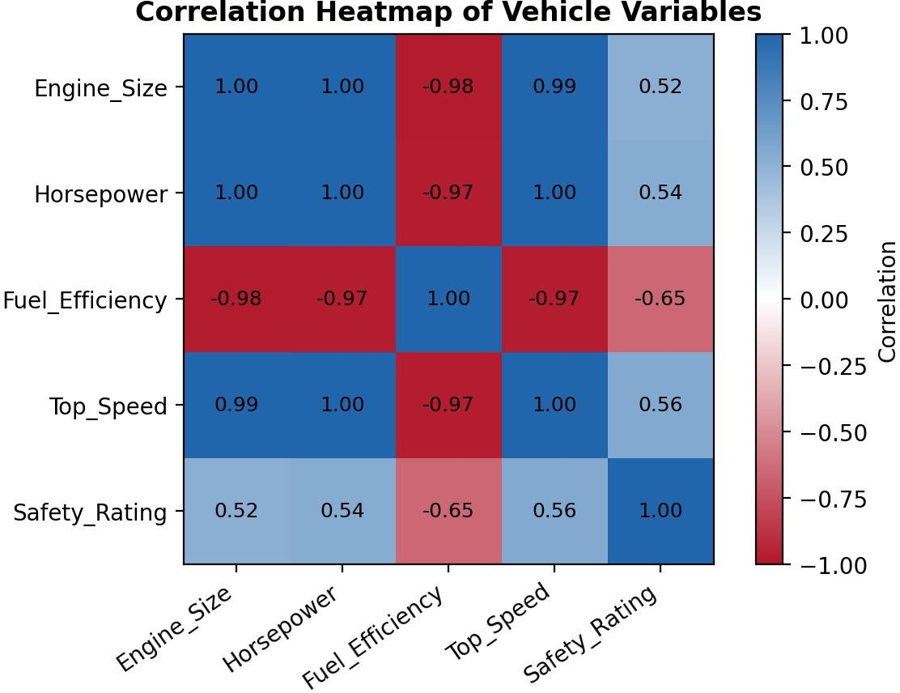
Output 3: Correlation Heatmap of Vehicle Variables

Observation:
Top_Speed is almost perfectly correlated with Horsepower (0.997) and Engine_Size (0.995), so these are the variables most strongly associated with it. Fuel_Efficiency has a strong negative correlation with Top_Speed (-0.97), which shows the trade-off: vehicles that go faster use more fuel per km. Safety_Rating has only a moderate positive link with Top_Speed (0.56), so it is influenced by performance only to a limited extent. Overall, engine size and horsepower drive vehicle performance, and fuel efficiency is what is given up in return. Engine_Size and Horsepower are themselves almost perfectly correlated (0.998), so

their effects cannot be separated, and with five vehicles the values should be read as trends and not as proof of cause.

PROGRAM 4: Interactive Vehicle Performance Dashboard in Tableau
In Tableau, design an interactive dashboard with bar charts and scatter plots, along with filters for Engine_Size and Safety_Rating, to highlight vehicles that balance fuel efficiency and high performance.

Steps in Tableau
- Save the dataset as an Excel or CSV file and connect to it in Tableau (Connect > Microsoft Excel / Text file).
- Sheet 1 (Fuel Efficiency Bar Chart): Drag Vehicle_ID to Columns and Fuel_Efficiency to Rows (SUM). Add Fuel_Efficiency to Label and rename the sheet "Fuel Efficiency".
- Sheet 2 (Top Speed Bar Chart): Drag Vehicle_ID to Columns and Top_Speed to Rows (SUM). Add Top_Speed to Label and rename the sheet "Top Speed".
- Sheet 3 (Scatter Plot): Drag Fuel_Efficiency to Columns and Top_Speed to Rows. Change each measure to Dimension-level (Analysis > Aggregate Measures off), drag Vehicle_ID to Label, Horsepower to Size and Safety_Rating to Color. Rename the sheet "Efficiency vs Speed".
- Create a new Dashboard (Dashboard > New Dashboard), set the size to Automatic, and drag the three sheets onto the dashboard area.
- Add interactivity: select each chart and click Use as Filter. Add Engine_Size and Safety_Rating filters (Show Filter > Apply to Worksheets > All Using This Data Source).
- Add the title "Vehicle Performance Dashboard" and test the filters in Presentation Mode.

OUTPUT:
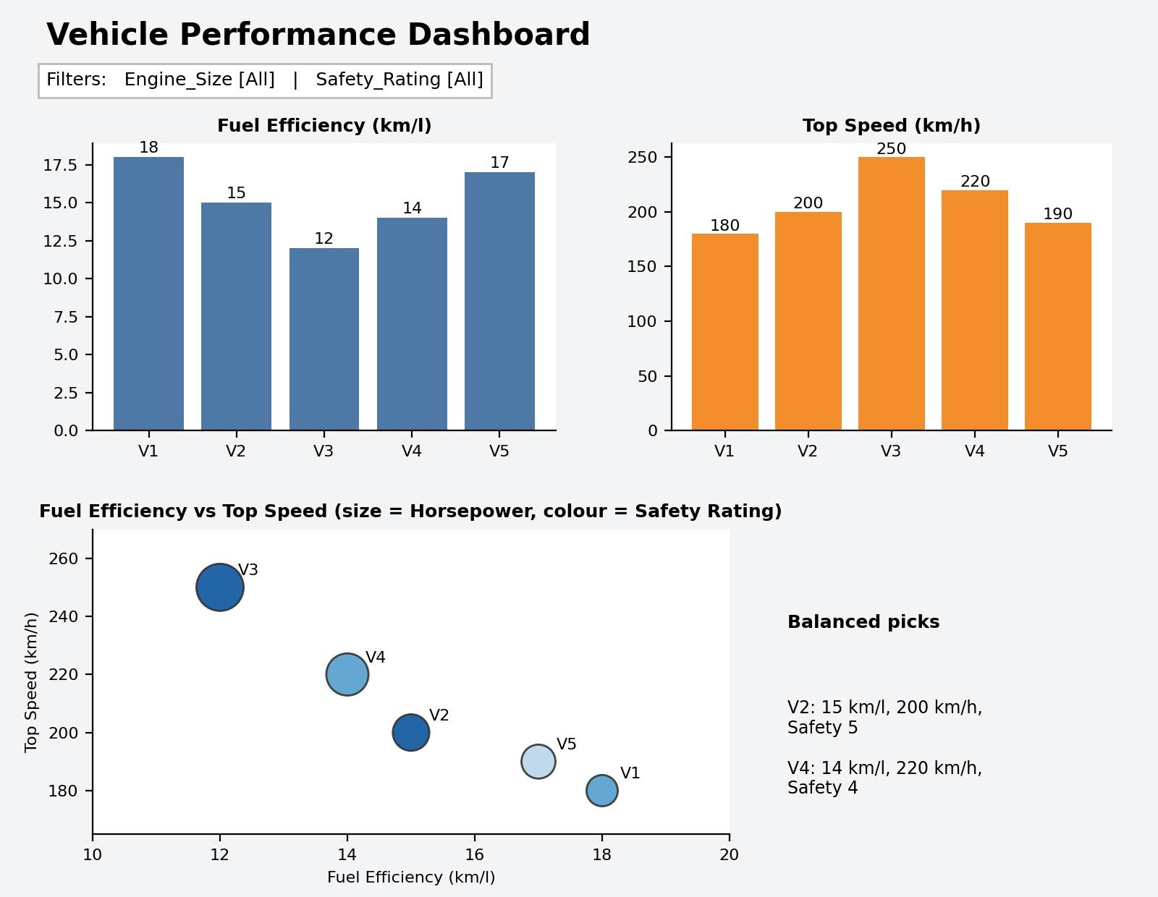
Output 4: Interactive Vehicle Performance Dashboard (Tableau)

Observation:
The bar charts show that V1 (18 km/l) and V5 (17 km/l) are the most fuel efficient but also the slowest (180 and 190 km/h), while V3 is the fastest (250 km/h) but the least efficient (12 km/l). The scatter plot falls from top left to bottom right, which confirms that no vehicle is best at both. V2 (15 km/l, 200 km/h, safety rating 5) and V4 (14 km/l, 220 km/h, safety rating 4) sit in the middle on both measures, so they give the best balance of efficiency and speed. V2 is the better choice when safety matters, and V4 when speed

matters more. Using the Safety_Rating filter to select rating 5 shows only V2 and V3, which makes this comparison easy.

Procedure
- Define the vehicle data in R as a data frame.
- Use ggplot2 with geom_violin() and geom_boxplot() to compare Fuel_Efficiency across Safety_Rating groups.
- Use geom_point() and geom_smooth() to plot Horsepower against Top_Speed, coloured by Engine_Size, and find the correlation with cor().
- Compute the correlation matrix of the numerical variables with cor() and draw it as a heatmap using geom_tile().
- Load the vehicle file into Tableau and build the bar chart and scatter plot worksheets.
- Combine the worksheets in a Tableau dashboard and add Engine_Size and Safety_Rating filters and actions for interactivity.

RESULT:
The vehicle performance data was successfully analyzed using a violin plot, a scatter plot and a correlation heatmap in R. Fuel efficiency decreases as the safety rating rises, and top speed is almost perfectly linked to horsepower (r = 0.997) and engine size (r = 0.995). An interactive Tableau dashboard was also created with Engine_Size and Safety_Rating filters, and it identified V2 and V4 as the vehicles that best balance fuel efficiency and performance.

Key Functions and Tools Used

Function / Tool | Purpose
data.frame() / factor() | Creates the vehicle dataset and treats Safety_Rating as a category.
geom_violin() / geom_boxplot() | Draws the distribution of Fuel_Efficiency in each Safety_Rating group.
geom_point() / geom_smooth() | Creates the scatter plot and the trend line.
cor() | Calculates the correlation between variables.
geom_tile() / scale_fill_gradient2() | Draws the correlation heatmap with a diverging colour scale.
Tableau Bar Chart / Scatter Plot | Compares vehicles on fuel efficiency, top speed and horsepower.
Tableau Dashboard / Filters | Combines worksheets and filters them by Engine_Size and Safety_Rating.

